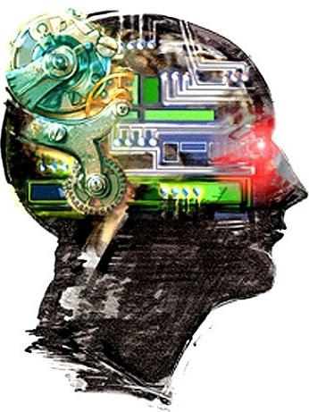  ARTIFICIAL INTELLIGENCE  Intelligent Agents | Abstract  An agent is anything that can be viewed as perceiving its environment through sensors and acting upon that environment through actuators.  Iftekhar Mahmud Towhid  CSTE 4103: Artificial Intelligence

  - Introduction
Computers are not very good at knowing what to do: every action a computer performs must be explicitly anticipated, planned for, and coded by a programmer. If a computer program ever encounters a situation that its designer did not anticipate, then the result is not usually pretty—a system crash at best, multiple loss of life at worst. This mundane fact is at the heart of our relationship with computers. It is so self-evident to the computer literate that it is rarely mentioned. And yet it comes as a complete surprise to those encountering computers for the first time.
For the most part, we are happy to accept computers as obedient, literal, unimaginative servants. For many applications (such as payroll processing), it is entirely acceptable. However, for an increasingly large number of applications, we require systems that can decide for themselves what they need to do in order to satisfy their design objectives. Such computer systems are known as agents. Agents that must operate robustly in rapidly changing, unpredictable, or open environments, where there is a significant possibility that actions can fail are known as intelligent agents, or sometimes autonomous agents.

  - Agents
An agent is anything that can be viewed as perceiving its environment through sensors and acting upon that environment through actuators.

Figure 1.1: An agent in its environment. The agent takes sensory input from the environment, and produces as output actions that affect it. The interaction is usually an ongoing, non-terminating one.

Human agent:
- Sensors: Eyes (vision), ears (hearing), skin (touch), tongue (gustation), nose (olfaction), neuromuscular system (proprioception)
- Percepts: At the lowest level – electrical signals from these sensors
  - After preprocessing – objects in the visual field (location, textures, colors etc.), auditory streams (pitch, loudness, direction) ...
- Actuators/effectors: limbs, digits, eyes, tongue etc.
- Actions: lift a finger, turn left, walk, run, carry an object etc.

Robotic agent:
- Sensors: cameras and infrared range finders for sensors
- Actuators: various motors for actuators

  - Agents
An agent’s behavior is mathematically described by agent function.
The agent function maps from percept histories to actions:
[f: P* A]
Practically it is described by an agent program which is the real implementation of an agent.
The agent program runs on the physical architecture to produce f
agent = architecture + program

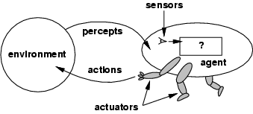

Figure 1.2: An agent in its environment. The agent takes sensory input from the environment, and produces as output actions that affect it. The interaction is usually an ongoing, non-terminating one.

    - Examples
Any control system can be viewed as an agent. A simple (and overused) example of such a system is a thermostat. Thermostats have a sensor for detecting room or device temperature. The sensed temperature is used to control the device it is attached to, i.e. refrigerator, iron etc.

  - Rational agent
- A rational agent is one that does the right thing. The right action is the one that will cause the agent to be most successful.

- Performance measure: An objective criterion for measuring the degree of success of an agent's behavior. E.g., performance measure of a vacuum-cleaner agent could be amount of dirt cleaned up, amount of time taken, amount of electricity consumed, amount of noise generated, etc.

- For each possible percept sequence, a rational agent should select an action that is expected to maximize its performance measure, given the evidence provided by the percept sequence and whatever built-in knowledge the agent has.

- Agents can perform actions in order to modify future percepts so as to obtain useful information (information gathering, exploration).

- Agents may be autonomous. An agent is autonomous if its behavior is determined by its own experience (with ability to learn and adapt).

- A Rational agent is not necessarily omniscient, i.e. it knows everything about the environment and is certain about the outcome of its actions.

    - Autonomous agents
- A system is autonomous to the extent that its own behavior is determined by its own experience.
- Therefore, a system is not autonomous if it is guided by its designer according to a priori decisions.
- To survive, agents must have:
- Enough built-in knowledge to survive.
- The ability to learn.

    - Omniscience
- An omniscient agent -
- Knows the actual outcome of its actions in advance
- Certain that there are no other possible outcomes
- However, omniscient agent is impossible in real world
  - Based on the circumstance, it is rational. As rationality maximizes the expected performance and perfection maximizes actual performance. Hence rational agents are not omniscient.

  - Designing an intelligent/rational agent: PEAS
PEAS: Performance measure, Environment, Actuators, Sensors
Performance measure:
An objective criterion for measuring the degree of success of an agent's behavior. The performance measure is defined by the designer.
Environment:
An agent operates in a particular environment. The environment can restrict the behaviors and actions of an agent. Obviously, the more restricted the environment, the easier the agent design is, since the agent has to deal with less factors of the environment.
Actuators:
An actuator is the mechanism by which a control system acts upon an environment. The control system can be simple (a fixed mechanical or electronic system), software-based (e.g. a printer driver, robot control system), a human, or any other input.
Sensors:
A sensor is a device which detects or measures a physical property and records, indicates, or otherwise responds to it.

We must first specify these settings for an intelligent agent design.

Consider, e.g., the task of designing an automated taxi driver:
- What are the performance measure?
- What is the environment?
- What are the actuators?
- What are the sensors?

    - Automated taxi driving system
Performance measure: Maintain safety, reach destination, minimize costs (fuel, tire wear), obey laws, provide passenger comfort etc.
Environment: Urban streets, freeways, traffic, pedestrians, weather etc.
Actuators: Steer, accelerate, brake, horn, speak / display etc.
Sensors: Video, sonar, speedometer, odometer, engine sensors, keyboard input, microphone, GPS etc.

Different aspects of driving may require different types of agent programs.

    - More examples

Agent type | Percepts | Actions | Goals | Environment
Medical diagnosis system | Symptoms, findings, patient’s interview | Questions, tests, treatments | Healthy patient, minimize costs | Patient, Hospital
Satellite image analysis system | Pixels of varying intensity and color | Print a categorization of scenes | Accurate categorization | Images form orbiting satellite
Part-picking robot | Pixels of varying intensity | Pick up parts and sort into bins | Place parts in correct bins | Conveyor belt with parts
Refinery controller | Temperature, pressure readings | Open, close valves, adjust temperature | Maximize purity, yield, safety | Refinery
Interactive English tutor | Typed words | Print exercises, suggestions, corrections | Maximize students’ score on test | Set of students

  - Agents programs
- A designer develops an agent program that implements an agent function.
- An agent program has the current perception p(t) as input.
- An agent program can store the previous perceptions p(0), p(1), ..., p(t–1).
- An agent program has an action a(t) as output.
- An agent program is the real implementation of an agent which runs on a physical architecture.

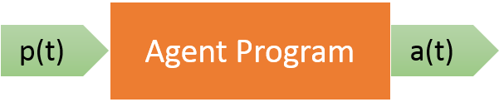
Figure: An agent program outputs an action given a perception

    - A simple agent program: Table lookup agent
A table-lookup agent is the simplest possible way we can think of to write the agent program. It operates by keeping in memory its entire percept sequence, and using it to index into table, which contains the appropriate action for all possible percept sequences.
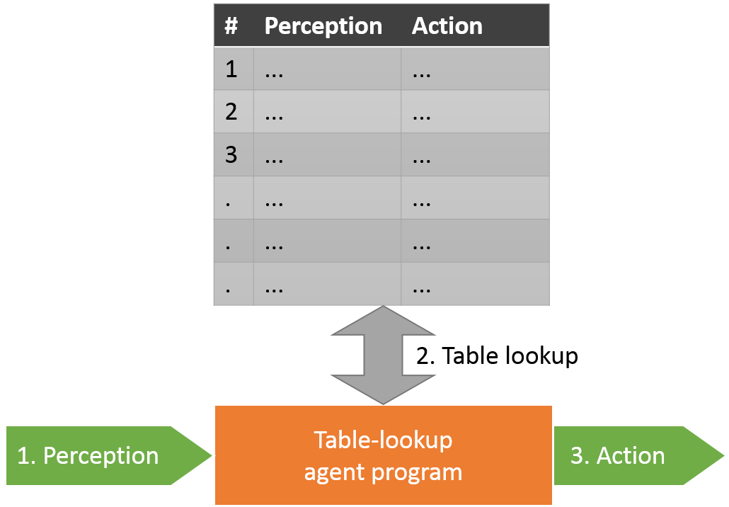
Figure: A simple table-lookup agent program

Drawbacks of table lookup agent program:
While table-lookup agent program is the simplest to implement, it is not realistic. There are some significant drawbacks:
- Requires huge look-up table for complex problems. For example: the table needed for something as simple as an agent that can only play chess would be about 35¹⁰⁰ entries.
- It would take quite a long time for the designer to build the table.
- The agent has no autonomy at all, because the calculation of best actions is entirely built-in. So if the environment changed in some unexpected way, the agent would be lost.
- Even if we gave the agent a learning mechanism as well, so that it could have a degree of autonomy, it would take forever to learn the right value for all the table entries.

    - Types of agent Programs
Four basic types in order of increasing generality:
- Simple reflex agents
- State/Model-based reflex agents
- Goal-based agents
- Utility-based agents
All these can be turned into learning agents.

      - Simple reflex agents
- A simple reflex agent selects actions based on its current perception or the world and not based on past perceptions. Therefore, no memory is required.
- Every possible perception is connected with an action called condition-action rule which has the form:
If condition then action
- The simple reflex agent has a library of such rules so that if a certain situation should arise and it is in the set of Condition-action rules the agent will know how to react with minimal reasoning.
- These agents are simple to work with but have very limited intelligence
- May fall in deadlock or infinite loop.

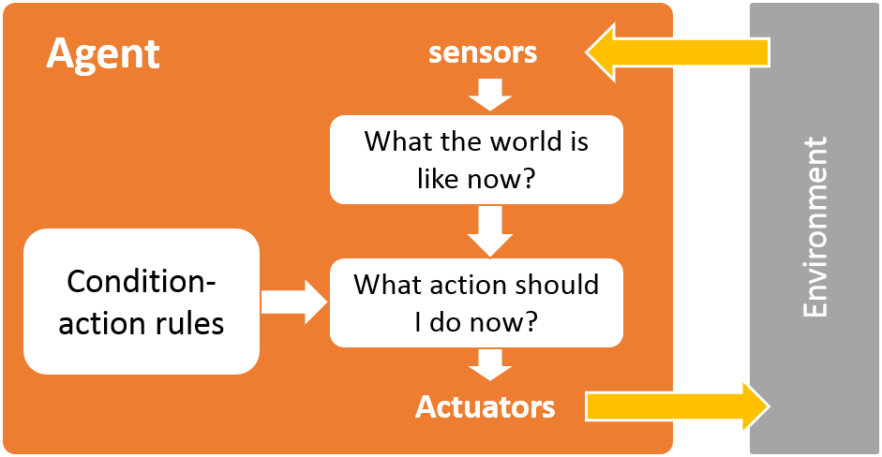
Figure: a simple reflex agent

      - Model based reflex agents
- Model-based reflex agents are made to deal with partial accessibility; they do this by keeping track of the part of the world it can see now. It does this by keeping an internal state that depends on what it has seen before so it holds information on the unobserved aspects of the current state.
- In order to update this internal state we need 2 things:
  - Information on how the world evolves on its own.
  - How the world is affected by the agents actions.
- Needed because sensors do not usually give the entire state of the world at each input, so perception of the environment is captured over time. "State" used to encode different "world states" that generate the same immediate percept.

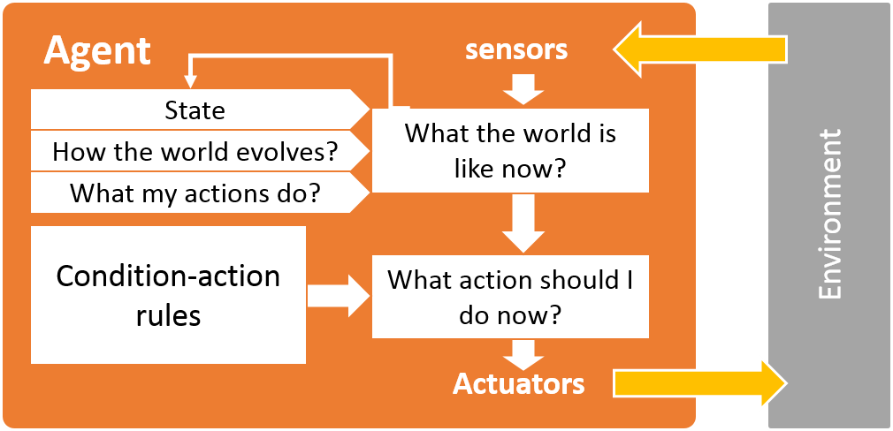
Figure: A model based reflex agent

      - Goal-based agents
- Keeping track of the current state is often not enough -- need to add goals to decide which situations are good.
- A goal-based agent has a set of goals or desirable situations. The agent can use these goals with a set of actions and their predicted outcomes to see which action sequence is most likely to achieve the goal(s).
- Achieving the goals can take one or more actions. Search and planning are two subfields in AI devoted to finding sequences of actions to achieve an agents goals.
- Unlike the previous reflex agents before acting this agent reviews many actions and chooses the one which come closest to achieving its goals, whereas the reflex agents just have an automated response for certain situations.
- Although the goal-based agent does a lot more work that the reflex agent this makes it much more flexible because the knowledge used for decision making is represented explicitly and can be modified.
- Deliberative instead of reactive.

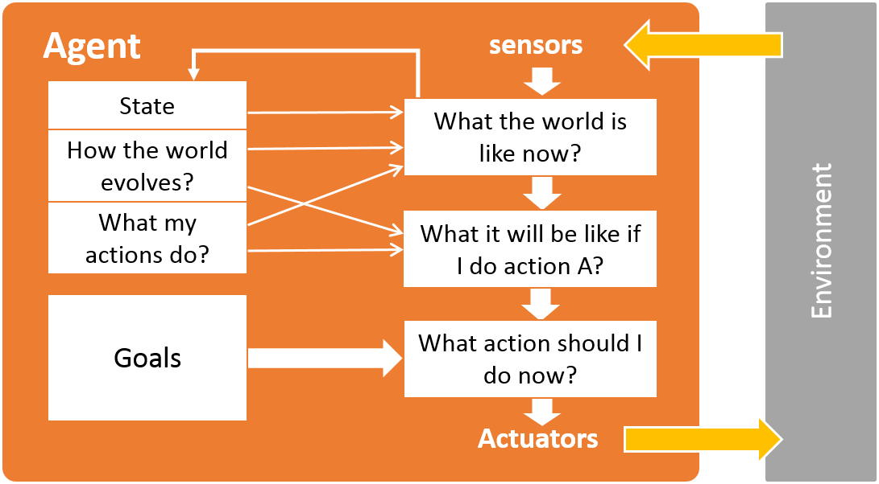
Figure: a goal-based agent

      - Utility-based agents
- Utility based agents have the means to decide among multiple possible alternatives called utility function.
- A goal specifies a crude distinction between a feasible and unfeasible state, but often need a more general performance measure that describes "degree of feasibility"
- Utility function indicates a measure of success or feasibility when at a given state.
- Allows decisions comparing choice between conflicting goals, and choice between likelihood of success and importance of goal (if achievement is uncertain)
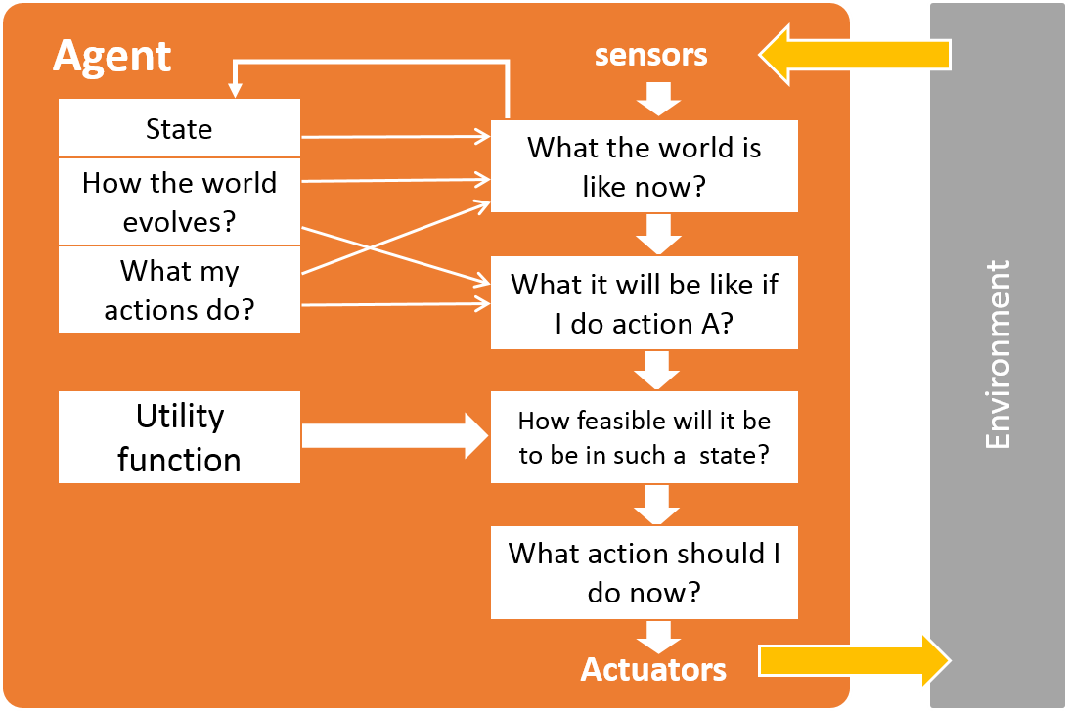
Figure: Utility based agent
    - Learning agents
When we expand our environments we get a larger and larger amount of tasks, eventually we are going to have a very large number of actions to pre-define. Another way of going about creating an agent is to get it to learn new actions as it goes about its business, this still requires some initial knowledge but cuts down on the programming greatly. This will allow the agent to work in environments that are unknown.

A learning agent can be split into the 4 parts shown in the diagram.
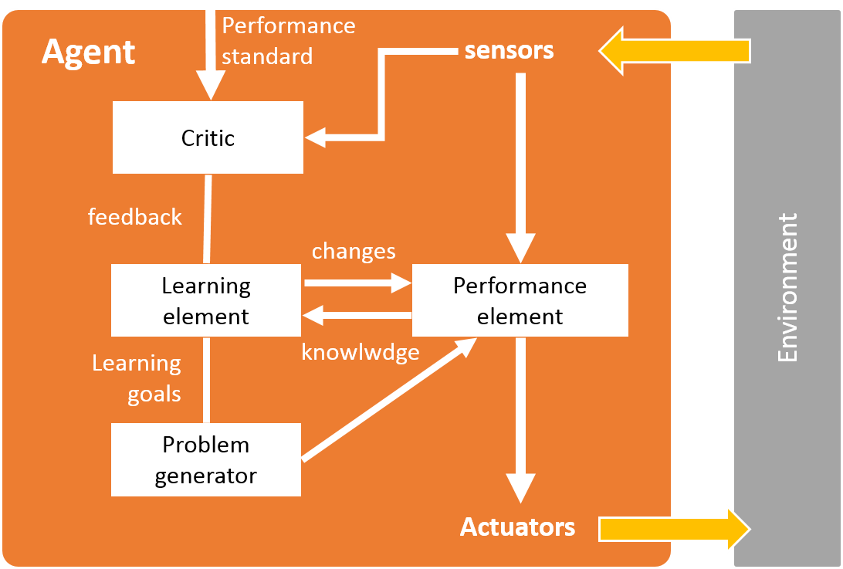
Figure: A learning agent

The learning element is responsible for improvements this can make a change to any of the knowledge components in the agents. One way of learning is to observe pairs of successive states in the percept sequence; from this the agent can learn how the world evolves. For utility based agents an external performance standard is needed to tell the critic if the agent’s action has a good or a bad effect on the world.

The performance element is responsible for selecting external actions, and this is considered to be the previous agents discussed.

The learning agent gains feedback from the critic on how well the agent is doing and determines how the performance element should be modified if at all to improve the agent.

The last component is the problem generator, the performance generator only suggests actions that it can already do so we need a way of getting the agent to experience new situations, and this is what the performance generator is for. This way the agent keeps on learning.

  - Environments
    - Types of environment

- Fully observable vs. partially observable
An agent's sensors give it access to the complete state of the environment at each point in time.

- Deterministic vs. non-deterministic( stochastic)
An environment is deterministic if the next state of the environment is solely determined by the current state of the environment and the actions selected by the agents. An inaccessible environment might appear to be non-deterministic since the agent has no way of sensing part of the environment and the result of its actions on it. We have to take into consideration the point of view of the agent when determining whether an environment is deterministic or not since the agent might have limited perception capabilities. If the environment is deterministic except for the actions of other agents, then the environment is strategic.

- Episodic vs. non-episodic
In an episodic environment, the agent's experience is divided into episodes which consist of a percept sequence and an action. Since episodes are independent of one another and the agent doesn't need to know the effect of its actions.

- Static vs. dynamic
An environment is dynamic if it changes while an agent is in the process of responding to a percept sequence. It is static if it does not change while the agent is deciding on an action i.e. the agent does not to keep in touch with time. An environment is semi dynamic if it does not change with time but he agent's performance score does.

- Discrete vs. continuous
If the number of percepts and actions in the environment is limited and distinct then the environment is said to be discrete.eg A chess board.

- Single agent vs. multi-agent:
An agent operating by itself in an environment.

    - Examples
Environment | Accessible | Deterministic | Episodic | Static | Discrete
Chess with a clock | Yes | Yes | No | Semi | Yes
Chess w/o a clock | Yes | Yes | No | Yes | Yes
Poker | No | No | No | Yes | Yes
Backgammon | Yes | No | No | Yes | Yes
Taxi driving | No | No | No | No | No
Medical diagnosis system | No | No | No | No | No
Image analysis system | Yes | Yes | Yes | Semi | No
Part-picking robot | No | No | Yes | No | No
Refinery controller | No | No | No | No | No
Interactive English tutor | No | No | No | No | Yes

  - Appendix (Terms reviewed)
Agent
An agent is anything that perceiving its environment through sensors and acting upon that environment through actuators
Percept
Agent’s perceptual inputs at any given instant
Percept sequence
Complete history of everything that the agent has ever perceived.
Agent function
A function mapping any given percept sequence to an action.
Agent program
Practical implementation of an agent.
Rational agent
A rational agent is one that does the right thing. For each possible percept sequence, a rational agent should select an action that is expected to maximize its performance measure, given the evidence provided by the percept sequence and whatever built-in knowledge the agent has.
Performance measure
An objective criterion for measuring the degree of success of an agent's behavior. The performance measure is defined by the designer.
Environment
An agent operates in a particular environment. The environment can restrict the behaviors and actions of an agent. Obviously, the more restricted the environment, the easier the agent design is, since the agent has to deal with less factors of the environment.
Actuators
An actuator is the mechanism by which a control system acts upon an environment. The control system can be simple (a fixed mechanical or electronic system), software-based (e.g. a printer driver, robot control system), a human, or any other input.
Sensors
A sensor is a device which detects or measures a physical property and records, indicates, or otherwise responds to it.

  - Exercises

